Top Orthopedic Advertising Strategies for 2020
By Justin Knott
May 15, 2020
Like any business, an orthopedic practice needs a steady stream of leads to survive in a competitive healthcare market. Steady leads are not required to generate revenue, but effective orthopedic marketing and orthopedic advertising strategies must be executed to convert them seamlessly.
If you’re here, then you’re wondering how you can drive more leads to your practice with precise orthopedic marketing techniques. If so, then you’ve come to the right place.
This complete guide to marketing an orthopedic practice will put you on the right track to improve the performance of your practice and usher in a new wave of profitability.

Get Your Orthopedic Surgeons on Video
Video marketing has become extremely popular in recent years. Rightfully so, it’s an extraordinary way to reach unique audiences, build credibility, and naturally refine leads.
One of our top tips for marketing an orthopedic surgeon is getting them to focus on creating educational videos.
Just take a look at these lucrative video marketing statistics for businesses.
- 85% of internet users in the United States watched video content on their personal devices.
- 54% of consumers want to see more video content from the brand or business they support.
- 88% of video marketers are happy with their ROI.
- Video marketers receive 66% more qualified leads every year than non-users.
As you can see, there are numerous terrific benefits to video marketing and you can leverage the activity to convert more leads for your orthopedic practice.
In the field of healthcare, it can be difficult for people to trust physicians. After all, there is a rigid degree of trust that must be maintained before someone entrusts a doctor with their health.
By getting your orthopedic surgeons on video, you can help build trust in your orthopedic practice.
Videos that introduce your providers, provide important information to prospective patients, and answer frequently asked questions, can lead to increased brand trust.
Having prospects see the human side of your providers can make your practice more likely to retain quality leads.
Do not forget that YouTube is owned by Google and is the second largest search engine.
That can yield big benefits in search visibility if you follow the right process for YouTube SEO when uploading your videos.
Check out these simple tips to get the most reach out of each video.
If you are struggling to get started with topics just write down common questions that patients ask you week in and week out.
That will help you come up with dozens of content topics that you know patients are looking for the answers to.

Use Automated Appointment Reminders to Decrease No Shows
Every year, millions of people miss their doctor appointments. There are several reasons why this is, but the fact of the matter is that your practice literally can’t afford to bleed through new business.
To decrease no shows for your orthopedic practice, simply use automated appointment reminders. This orthopedic marketing hack, allows you to remind your patients about their scheduled appointment times – because let’s be honest – people naturally forget about things.
Although appointments are important from a health perspective, people may forget they have one, leading to potential health risks. Also, automated appointment reminders are instrumental from a sales standpoint.
If you notice that a person keeps missing appointments, you can follow-up with them to formulate a solution for their problem. Whatever the case is, automated appointment reminders can help you steer your patients to your practice on time and refine them accordingly.

Generate New Reviews for Locations & Providers
Online reviews can make or break your business.
Don’t just take our word for it.
According to BrightLocal’s Local Consumer Review Survey, the following insights are true:
- 86% of people read reviews of local businesses.
- People typically read an average of 10 reviews before they feel ready to trust a local business.
- 57% of people will never work with a local business that has less than 4 stars on Google, Facebook, or Yelp.
- 91% of 18-34-year-olds trust online reviews as much as word-of-mouth recommendations.
As you can see, generating reviews for your locations and providers is extremely important to your status as a credible practice. The most effective way of generating new reviews for your orthopedic practice can be by simply asking your patients and their families to leave honest reviews on Google, Facebook, or Yelp.
The more reviews you receive, the more prospective patients will be able to trust you.
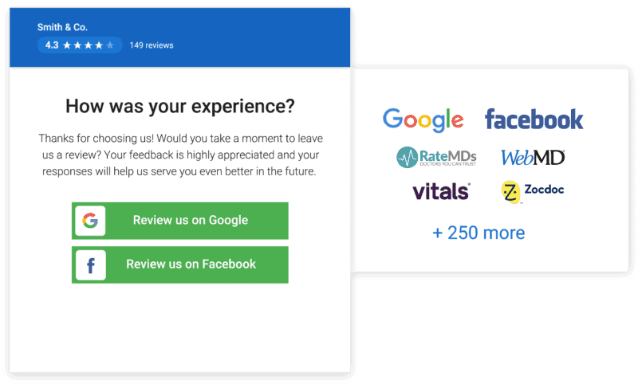
We always recommend leveraging a review generation software to make adoption and adding into your existing workflows that much easier.

Harness the Power of Orthopedic Advertising with Google Ads
You’ve likely seen a Google ad conducting a personal search for a product or just by browsing some information. Make no mistake – Google ads are pivotal to orthopedic surgeon advertising. Therefore, if you don’t have a Google ad campaign for your practice, then it’s time to develop one.
Setting up a Google Ads campaign can help drive targeted keyword search engine traffic to your website. With the correct research and landing page optimization, it is possible to drive highly-qualified surgical and non-surgical leads to the practice.
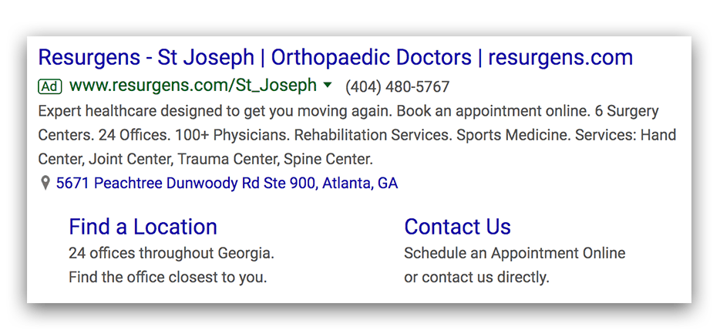
The advantage of Google Ads over social media ads can be the fact that the searcher already has a highly level of purchase intent because they are already on the search to some level for the solution that you provide.
You just need to ensure that you are striking the balance on your landing pages between a simple focus on conversion and proving enough content value to convert them.

Leverage On-Page SEO to Increase Organic Traffic
On-page search engine optimization (SEO) is the process of making your website ready to rank online. Here are the following areas of on-page SEO that mean the most to your web ranking:
- Metadata – Including keywords in your URL, title tags, and meta description can help your website show up for relevant searches.
- Images – Are your images correctly optimized? This can affect your site speed, which is a major factor in how long people will stay on your site and how search engines will rank it.
- Keywords – Keywords are search terms people use to find information. Embedding keywords properly throughout your website will improve your overall SEO ranking.
- Value – Do you have an FAQ section to answer your prospects’ questions? Is your site structured well from your navigation bar to your footer? The value of your website will be determined by search engines and play a large role in your web ranking.
The best way to gauge the viability of your on-page SEO performance is by performing an SEO audit of your website. An audit will provide you with diagnostic insights on the issues that exist on your website and how you can improve it.
Check out this video for more tips on SEO strategies for your website’s pages.

Promote the Orthopedic Practice Via Guest Posts & Podcasts
Another amazing orthopedic marketing strategy is leveraging content marketing. It is a proven method of establishing your business as an authority and growing organic search traffic.
This is also true for healthcare organizations. If you want to spread your expertise online, publishing a guest post or column on an authoritative website is a great way to start.
Prospects will be more comfortable to business with you if you have published thought articles on popular websites like WebMD and Science Daily.
Receiving a feature on a popular medical podcast is also an effective way of reaching a broad audience. 32% of the population in the U.S. listen to a podcast every month. It’s also a creative way of building your brand online.
Another major benefit to guest posting and podcasting is you gain a high-quality backlink out of it.
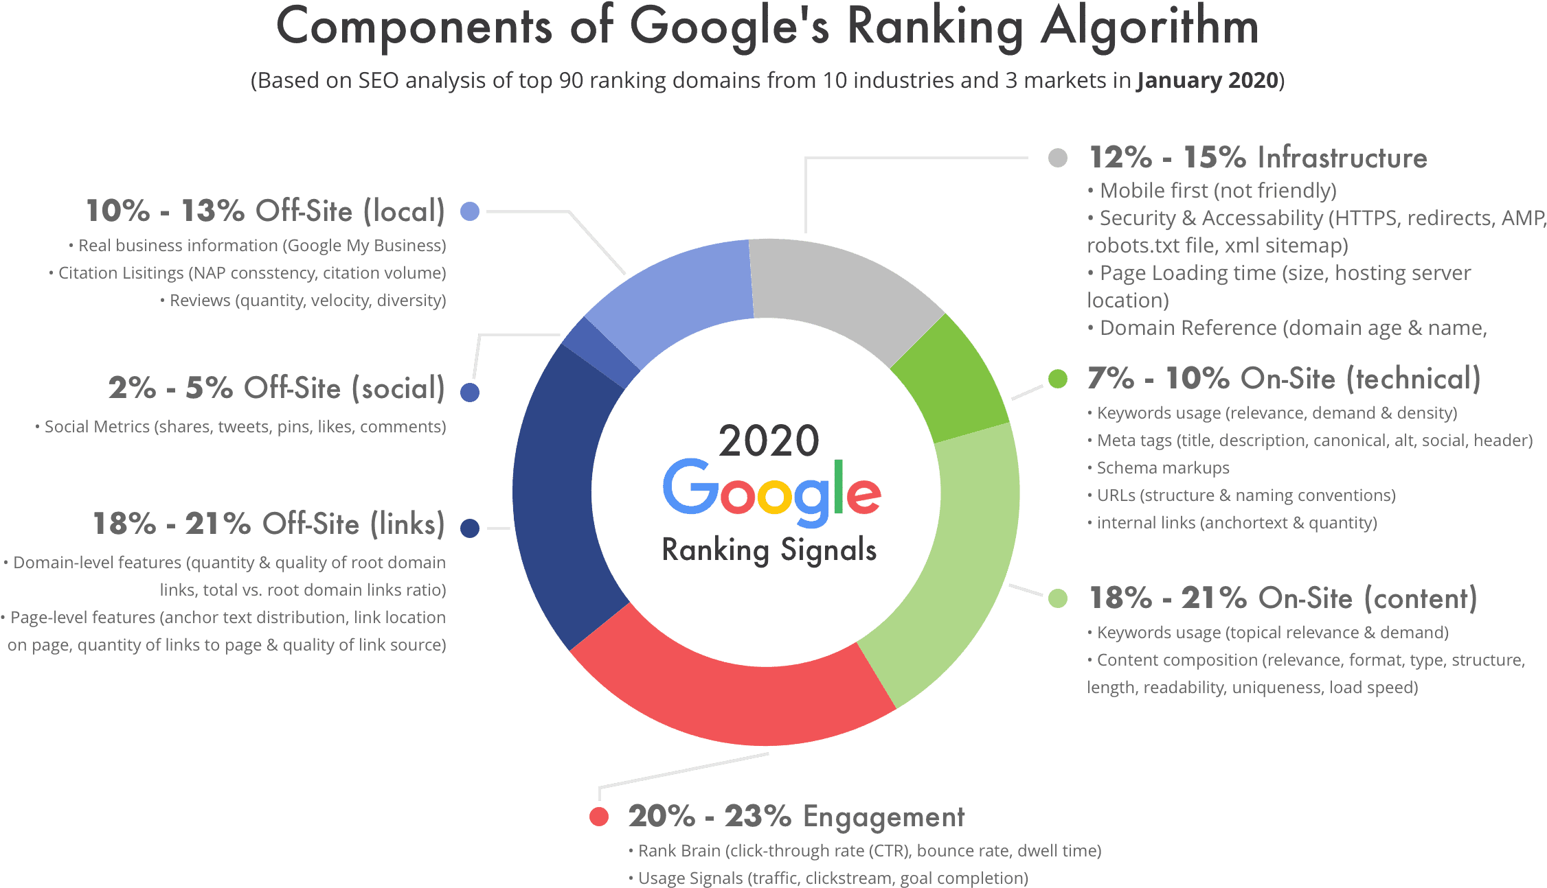
Backlinks are if not the #1, the #2 search ranking factor for Google’s algorithm.
So, they are critical to grow.
We even wrote an in-depth article on why doctors should start a podcast and how to do it that is worth checking out.

Unify & Manage Practice & Provider Listings
Your online listing is how your prospects will interact with your practice. Your listing contains important information that has to be 100% accurate. Otherwise, you could miss out on wide-open sales opportunities.
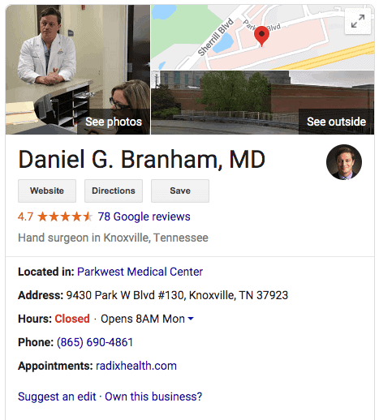
Often, when marketing orthopedic practices they make the mistake of having multiple listings that contain the same information. This can confuse prospects. Therefore, unify duplicate listings if any exist.
More importantly, you’ll need to manage your provider listings to ensure that your information is always correct.
Start with the most important provider listings sites like Healthgrades, Vitals, CareDash and RateMD.
This will help in ranking for searches like “knee replacement specialist near me” that are valuable keywords to rank #1 in local search.
Also, 89% of consumers read businesses’ responses to reviews. Keeping your listings accurate and properly managed can lead to fewer headaches and more success with drawing prospects from your online presence.

Geofencing for Orthopedic Surgeon Advertising
You may think geofencing ads are something out of a sci-fi book. However, the concept is quite simple. Geofencing for orthopedic advertising is the process of using a virtual boundary around a specific region to deploy targeted ads inside of that geographical area.
Let’s explain that even further. With geofencing ads, you can send customized ads to prospects based on a predetermined area they enter. For example, if you’re an orthopedic doctor in Atlanta, you could choose to geofence CrossFit gyms or trampoline facilities because unfortunately people get injured in these places often.
Geofencing ads give users the ability to send laser targeted ads with high success rates.
This is a highly effective orthopedic surgeon advertising technique.
We have seen it used in great effect for the client mentioned above that has orthopedic urgent care locations by targeting sports fields, trampoline and play facilities, and more.

Invest in an Analytics Dashboard
Marketing is a numbers game. You won’t win if you make premature judgments about your strategy without the numbers to back it up.
Investing in an analytics dashboard will put all of the important metrics of your website right in front of you.
This way, it’s much easier to track the ROI of your orthopedic marketing campaigns and get more money from your marketing spend.
And you do not have your analytics spread across multiple websites like Google Analytics, Google My Business, lead forms, and more.
That is why we make it a point to ensure all of our clients have access to our marketing analytics dashboards so they can quickly make executive-level decisions about their orthopedic marketing program.

*The contact information below is for Intrepy.
Wrapping up Orthopedic Marketing Strategies:
There are several ways you can market your orthopedic practice, as evidenced above. To put real professionals that specialize in orthopedic marketing in your corner, give us a call at (770) 462-8645 to learn more about how we can help you and your medical practice today.
Original Article Link: https://intrepy.com/orthopedic-marketing-strategies

